Neumont University

Name Generation
Design Specification
Matthew Grohman
Andy Cordes
8/17/2007

Contents

1 Introduction 3
2 Feature Overview 4
2.1 Preference Profiles 4
2.2 Omit Words from Predicates 4
2.3 Constraint Names 4
2.4 Acronyms 4
2.5 Differentiate Table and Column Abbreviations 5
2.6 Space Control 5
2.7 Case Control 5
2.8 Name Length 5
2.9 Subtyping 5
2.10 Role Names 5
2.11 Composite Identifiers 6
2.12 Name Generation – General TAB 7
2.13 Name Generation – Abbreviations TAB 8
2.14 Name Generation – Targets TAB 9
2.15 Name Generation – Supertypes TAB 10
2.16 Name Generation – Composite IDs TAB 11
3 Design Considerations 12
3.1 Assumptions & Dependencies 12
3.2 General Constraints 12
3.3 Goals & Guidelines 12
3.4 Development Methods 12
3.4.1 Integration to NORMA tool 12
4 Conclusion 13
5 Revision & Sign-off Sheet 14

Introduction
When a user elects to generate a relational schema and a DDL for create a database or code for an object model, the information from the ORM conceptual model is passed between several different levels in different formats. During one of the transitions, before the creation of the relation model, table and column names must be generated from role names, role player names, and other conceptual information. This process is hereafter referred to as “name generation”.
Ideally, the NORMA tool will be set up to use third party name generator providers for the process of name generation. We plan for the tool to come with our own default generator, but at the moment we have no such thing. There is just a very basic algorithm hard coded in. This feature development concerns creation of a better algorithm and a reworking of the name generation setup to operate as intended.
Primarily, we need to set up an algorithm to run as a provider, and allow the use of other third-party providers with the tool. This should include development of a new algorithm that should provide relatively intelligent column and table names using default settings without preference customization from the user.
The secondary idea of the new name generation specification is to give the user much more refined and powerful control over naming before the actual generation. It should provide the necessary options that allow a user to sufficiently customize the generation so that he or she will get the desired and appropriate names as a result.

Feature Overview

The first order of business is to set up the current basic name generation algorithm to work with the NORMA tool as though it were a third party custom provider. Second, we need to refine this algorithm to produce a higher quality result. At the moment, we do not have all the information needed to do this at the time of generation. However, this is currently being worked on, so the algorithm will be improved as soon as it is possible to do so. Meanwhile, development should begin on the customization and preference features detailed below.

The following is a compilation of the particular features that need to be implemented once the initial name generation provider is completed, each with a short description:

Preference Profiles
The user will be able to create, save, and load preference ‘profiles’ that represent a certain collection of the name generation configuration options, including a default profile with default options. The profiles are unrelated to the user and the model, and will be saved and loaded separately.

Omit Words from Predicates
Common predicate words that have no real relevance to the model such as ‘was’ will have an option to be removed from name generation. These words are not case sensitive. This should just be a configuration option, and is not model or target specific.

Constraint Names
Options will be given to specify a pattern for constraint names. Names can be set up to use any combination of the following: target table name, source table name, constraint type such as “FK”, the constraint number, and any static characters such as underscores.

Acronyms
Similar to abbreviations, acronyms will allow the user to specify how names should be shortened. Acronyms will be used to shorten a group of words instead of just a single word as with abbreviations. A global set of abbreviations can be set, as well as separate abbreviations based on the generation target.

Differentiate Table and Column Abbreviations
Currently, when abbreviations are set for name generation, those abbreviations apply indifferently to both table and column names. The new name generation will have the ability to mark particular abbreviations to be only used for particular targets, or even specific components of the target, such as table, column, or constraint names.

Space Control
The user will have control over how spaces are translated. This will include options such as: omitting all spaces, replacing with underscores, or retaining the spaces where possible. Space control is target specific.

Case Control
The user can specify the type of casing to be used: Camel, Pascal, Upper, or Lower. Casing is target specific.

Name Length
Currently, the NORMA tool algorithmically shortens any names that are over 30 characters in length. Instead, the tool will give an error if a name ends up longer than allowed for the specific generation target (including any prefixes or suffixes), and prompt him or her to shorten it manually. However, the old algorithm will be retained and an option will allow for it to be used. The option for its use is target specific, allowing different lengths to be specified for different targets.

Subtyping
The user will be able to set a preference profile option specifying whether to skip all subtype relationships when generating names. Additionally, the user will be able to toggle this option for individual object types. This option is specific to each model and is not saved to the profile.

Role Names
Role names will be used in place of the object type name when generating column names for tables with a reference to the object type. If the role name is not supplied, one will be generated from the predicate text.

Composite Identifiers
Customization options will be given for names generated for compositely identified object types. The user will be able to select which non leaf nodes will be included in name generation for composite identifiers. This will allow both of the following cases to be specified:
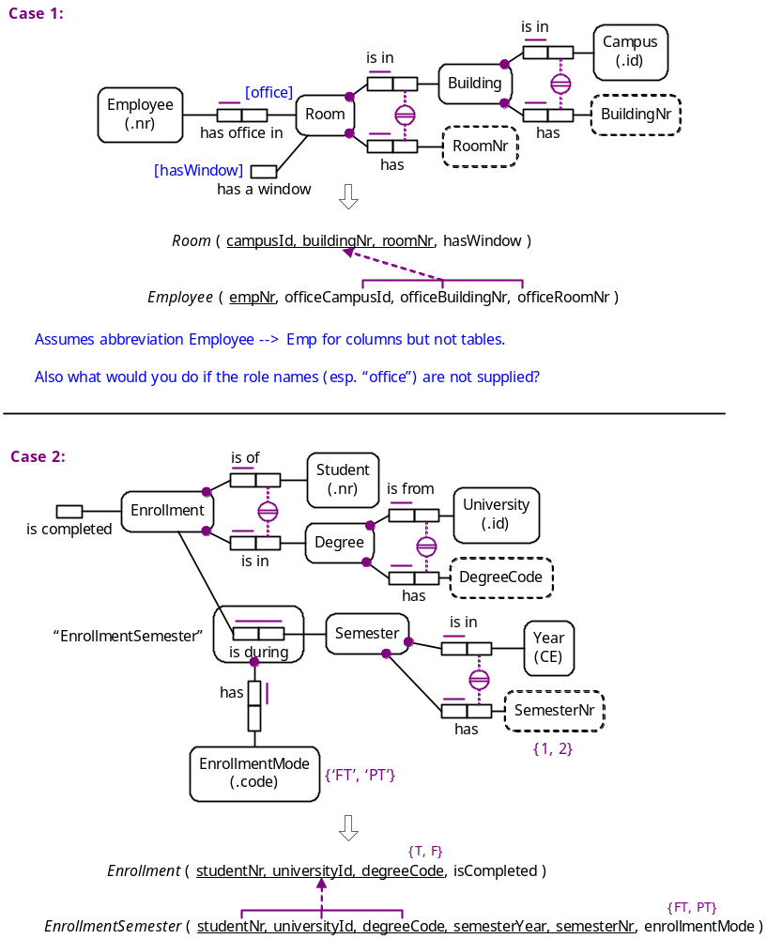

Name Generation – General TAB
When the user elects to use our name generation provider, two properties will be added, one to bring up a dialog with configuration options, and another for profile editing. Following are screen shots of the configuration dialog (each tab shown below in a separate image):

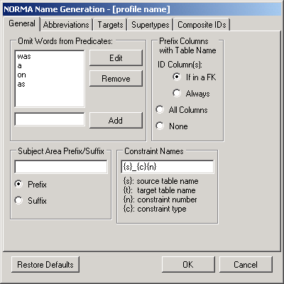

Note:
If no profile has been associated with a particular ORM model, the first time the dialog is invoked it should come up with default configuration settings. After settings have been saved, any following invocations of the dialog will bring up the current settings. At any time the “Restore Defaults” button can be clicked to restore all options to their default settings. Following the hyphen on the title bar where it says “[profile name]” will be the name of the current profile associated with the model. If no profile is being used, it will not display the hyphen or anything following it. If a profile is being used, any changes made will affect the profile.

Name Generation – Abbreviations TAB

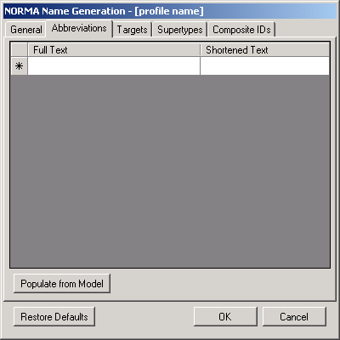

Note:
These are global abbreviations or acronyms that will always be applied, regardless of target. They are case sensitive.
“Populate from Model” will automatically add rows for each object type in the model, with shortened text defaulting to be identical to the full text. The user can then go in and easily change the shortened text for any rows desired.

Name Generation – Targets TAB

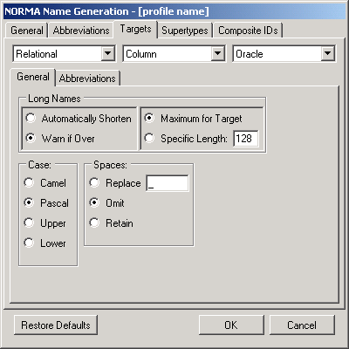

Note:
Here you can modify target specific options. The first combo box will have the basic types of targets, i.e. “Relational” or “Code”. The second will have different types of names for that type of target, i.e. “Column” or “Table”. The third will have the specific targets for the selected basic type, i.e. “sql” or “DB2”. Each combo box will additionally have an “(all)” option, that will cause changes made to modify the settings for every selectable option in the combo box.
The abbreviations tab looks identical to the one for global abbreviations, the only difference being that these are target specific.

Name Generation – Supertypes TAB

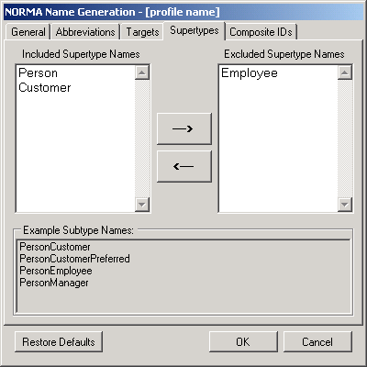

Note:
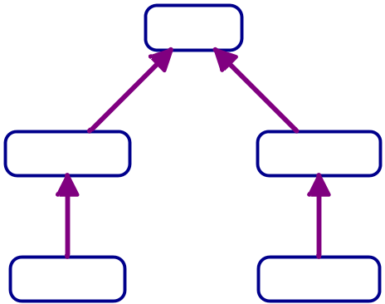

Supertypes will also have a new property on the conceptual model defining whether they are included or excluded from the names generated for their subtypes. The listboxes on the “Subtyping” tab will be initially loaded based on each subtype’s property, but can be changed from here as well. Changes made here should be propagated back to the concept model.
Each super type chain will show an example at the bottom of what the names will look like, updating when names are included or excluded.

Name Generation – Composite IDs TAB

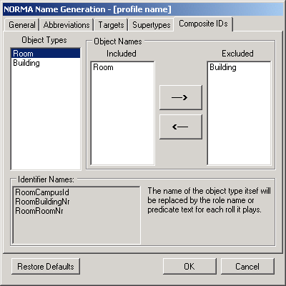
Note:
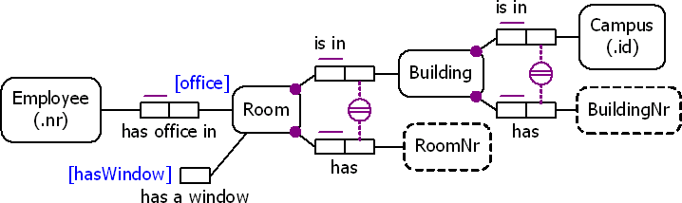

Similar to subtypes, the user will be able to toggle each node in the chain of a compositely identified object to be included or excluded from the name. The listbox on the left will be automatically loaded with any object types that have composite identifiers. Selecting one of these object types will cause the included listbox to be populated with all non leaf nodes in the identifier. The user can then move them back and forth from included to exclude as desired. The generated names for the identifiers will be shown at the bottom, using the actual object name instead of role names.

Design Considerations
Note: These sections will be filled in as Architectural Decisions are made.

Assumptions & Dependencies

General Constraints

Goals & Guidelines

Development Methods

Integration to NORMA tool

Conclusion

Revision & Sign-off Sheet

Change Record
Date | Author | Version | Change Reference
8/17/07 | Matt Grohman | 1.0 | First Approved Version

Reviewers
Name | Date
Terry Halpin
Dick Barden

Distribution
Name | Position
NORMA Dev Team
Boston Scientific Team

Document Properties
Item | Details
Document Title | Name Generation
Author | Matthew Grohman & Andrew Cordes
Creation Date | 7/16/2007
Last Updated | 8/17/2007 10:00 AM by acordes

